**Types of Statistical Data:**

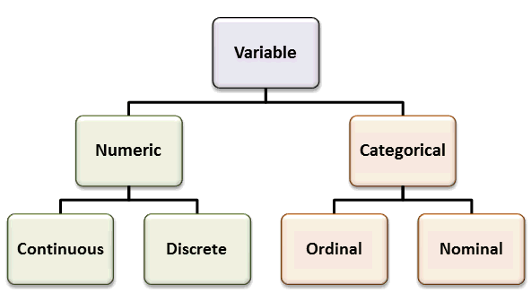

**Numerical data(quantitative data).**

These data have meaning as a measurement, such as a person’s height, weight, or they’re a count, number of heads in 10 coin flips, The number of customers walking into a store on any given day etc.

Numerical data can be further broken into two types: discrete and continuous.

* **Discrete variables**are countable in a finite amount of time. For example, you can count the change in your pocket. You can count the money in your bank account. You could also count the amount of money in everyone’sbank accounts. It might take you a long time to count that last item, but the point is—it’s still countable.
* **Example2:**

If your variable is “Number of Planets around a star,” then you can count all of the numbers out (there can’t be an infinite number of planets). That is a **discrete variable**.

* **Continuous data represent measurements; their possible values cannot be counted** and can only be described using intervals on the real number line. **Continuous Variables** would (literally) take forever to count. In fact, you would get to “forever” and never finish counting them. For example, take age. You can’t count “age”.
* **Why not?** Because it would literally take forever. For example, you could be:  
  25 years, 10 months, 2 days, 5 hours, 4 seconds, 4 milliseconds, 8 nanoseconds, 99 Pico sends…and so on.
* If your variable is “Temperature in Arizona,” how long would it take you to write every possible temperature? It would take you literally forever, hence it is a continuous variable

**Categorical data(Qualitative data):**

**Categorical Data**: represent characteristics such as a person’s gender, or the types of advertisement they like( those variables that can be put into categories). For example, the category “Toothpaste Brands” might contain the variables Colgate and Aquafresh etc.

Categorical data can be further broken into three types: Binomial, Nominal and ordinal

## **Binomial Data: Binary**data place things in one of two mutually exclusive categories: right/wrong, true/false, or accept/reject.

**Nominal values** : Another name for categorical variable.( i.e. nominal data that has no order). Therefore if you would change the order of its values, the meaning would not change. You can see two examples of nominal features below: Languages one can speak (English,Hindi,French,German,Kannada)

# Ordinal Data: similar to a categorical variable, but there is a clear order. For example, income levels of low, middle, and high could be considered ordinal. Eg2: Our educational background: elementary, high school, undergraduate, graduate, post graduate

# .